**INTRODUCTION TO LINUX EXERCISE**

**Q1.** Create a directory "exercise" inside your home directory and create a nested(dir1/dir2/dir3) directory structure inside "exercise" with a single command.

**Ans -**

First go to home directory of user with “cd ~” command and create a directory named “exercise” using ‘sudo mkdir exercise’ command and enter the user password.Then go inside exercise directory with cd exercise and run following command to create nested directories - ‘sudo mkdir -p dir1/dir2/dir3’. -p flag is used to create nested directories in parent directory (one inside other) separate by /.

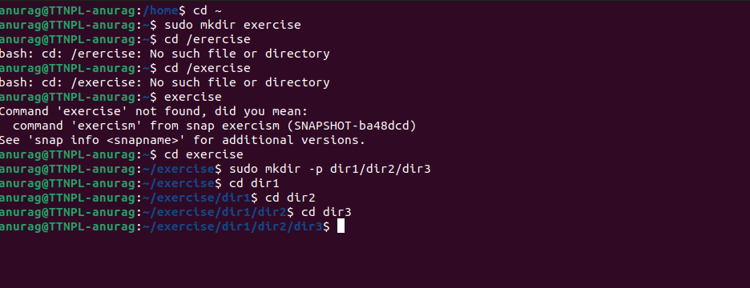

**Q1. (a).** Create two empty files inside dir2 directory: emptyFile1, emptyFile2 in single command.

**Ans.** change to directory in which we have to create files by cd /exercise/dir1/dir2.

Empty files can be created using touch command and we create two files with sudo as ‘sudo touch exptyFile1 emptyFile2’.

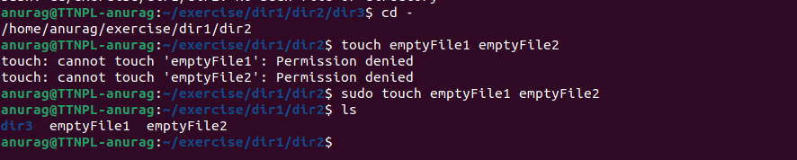

**Q1. (b).** Change the timestamp of empty File1, emptyFile2 which are exist in dir2.

**Ans.** We can modify the timestamp of the file using touch command with -m flag as - ‘sudo touch -m emptyFile1 emptyFile2’ this will modify the time to current time.

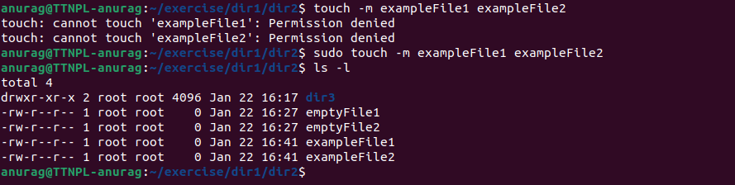

**Q1. (c).** Create one file file1.txt containing text "hello world" and save it.

**Ans.** - An empty text file can be created with cat > file1.txt and give it content whatever you want to give like ‘hello world’ then press ctrl+c to quit and save the file.

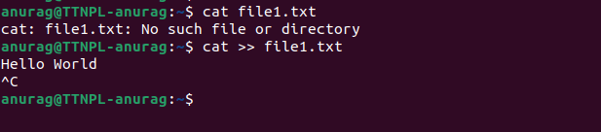

**Q2 .** Find a "passwd" file using find command inside /etc. copy this files as passwd_copy and then rename this file as passwd_backup.

**Ans.** - To find a file go to specific directory location using using cd as cd /etc and use ‘find’ command to look for the specific file in that directory as ‘sudo find -name passwd’

Copy this passwd file to a new file ‘passwd_copy” using ‘sudo cp passwd passwd_copy’ command in the same directory and rename it to passwd_backup using ‘sudo mv passwd_copy passwd_backup’

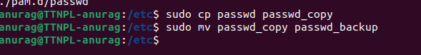

**Q2.(a).** Try reading passwd_backup file in multiple tools: less,more,cat,strings etc and find the difference in their usage.

**Ans. -** while using cat passwd_backup command it shows whole content of the file at once in terminal as

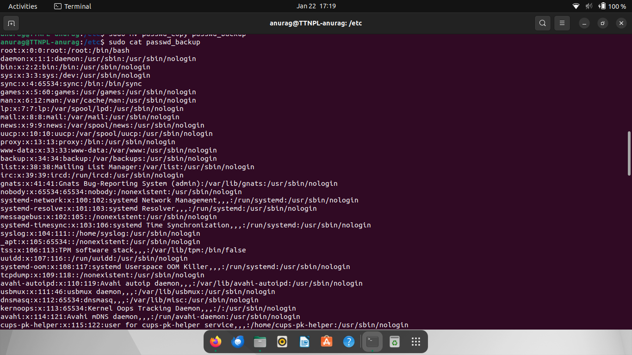

And using less passwd_backup command it opens a window with showing content fit in that one window only and load more content when pressing enter . as

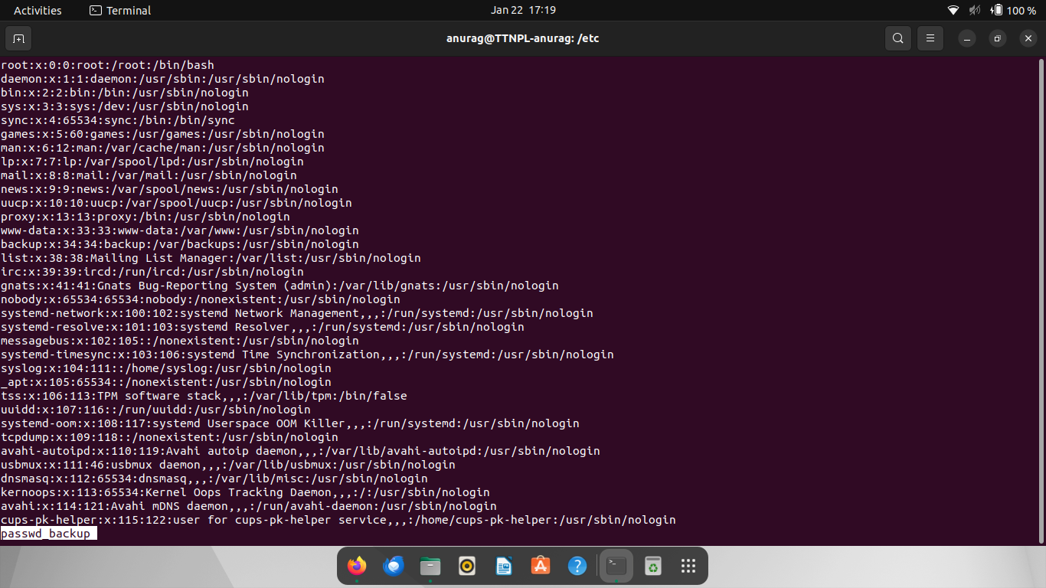

And with more passwd_backup command it shows contents of file in window and load more 2% when asked as

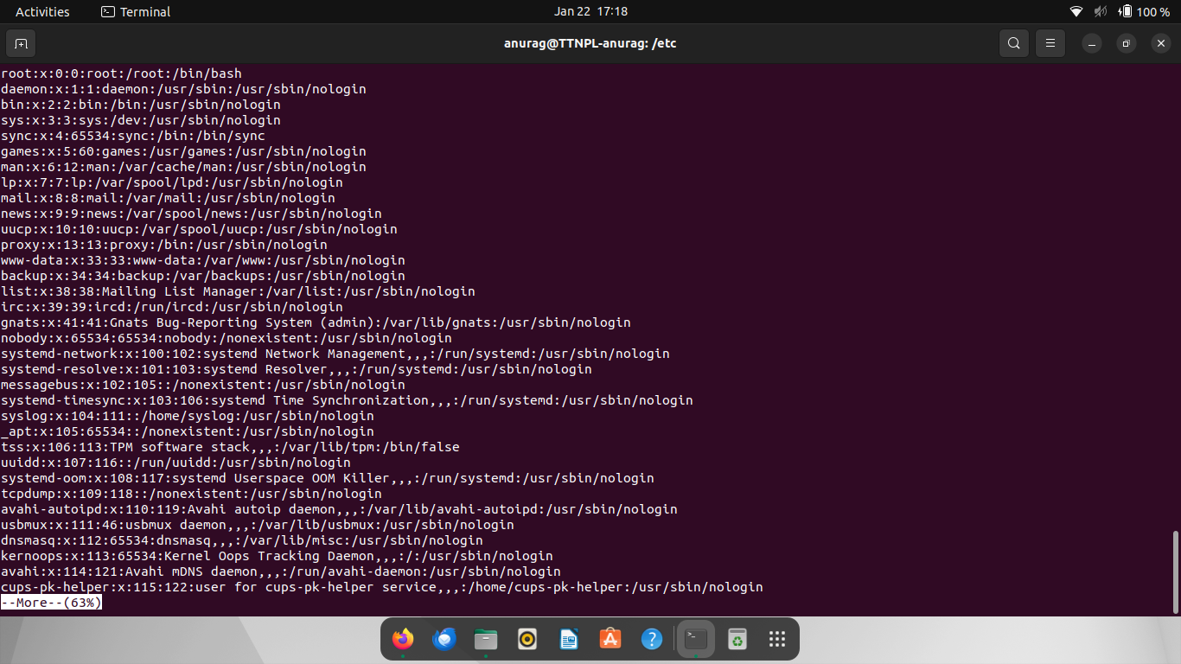

Using strings passwd_backup command it shows line wise string like cat command

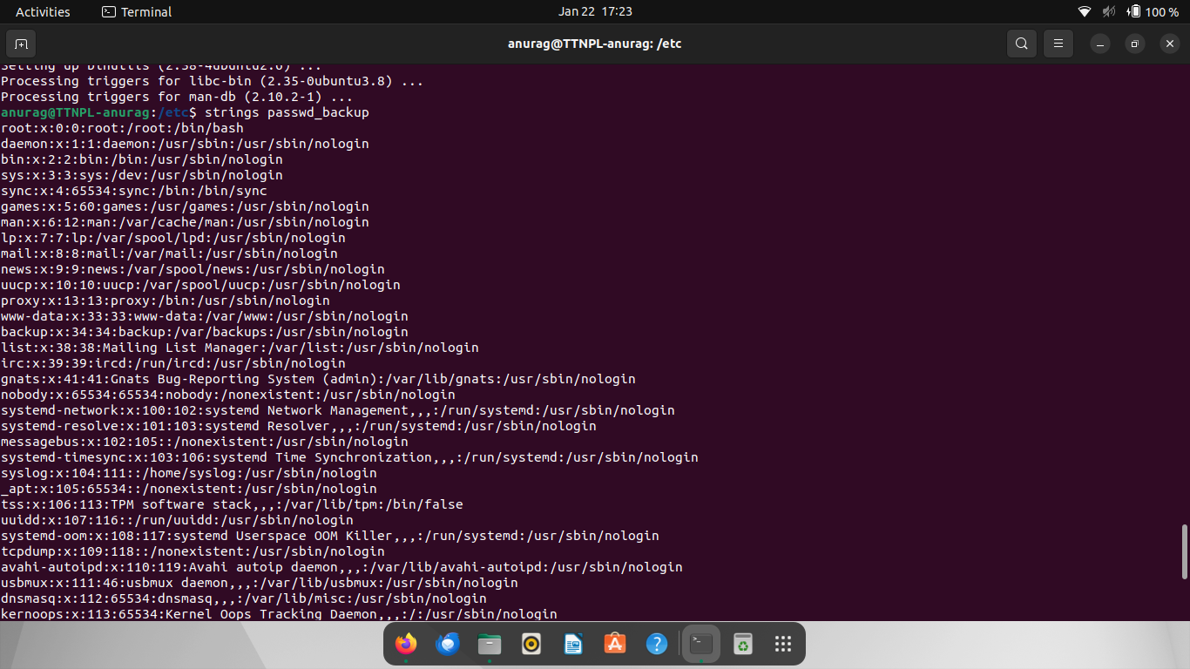

**Q2.(b).** Find out the number of line in password_backup containing "/bin/false".

**Ans. -** grep command can be used to match the expression in file with -c flag to ount the number of lines in which it occurs as ‘ grep - c “/bin/false/” passwd_backup’.

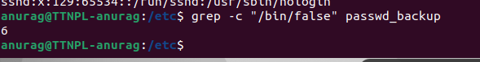

**Q3.** Get the first 5 lines of a file “password_backup” and Redirect the output of the above commands into file "output". Also, get the lines 6-10 from the above file.

**Ans.-** By default head command used to view the first 10 lines of the file but using head - n (n=no of lines) we can get first n random no. of lines from the file as ‘head -5 passwd_backup’ and copy the lines in output file using bash command with -c flag as

‘Sudo bash -c head -5 passwd_backup > output.

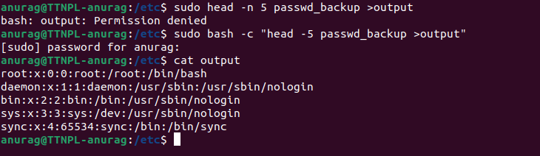

**Q3.** Create a "test" user,create its password and find out its uid and gid.

**Ans. - ‘**sudo useradd username’ command is used to add the new user and ‘sudo passwd username’ to set its password and ‘used id username’ command to look at their uid and gid.

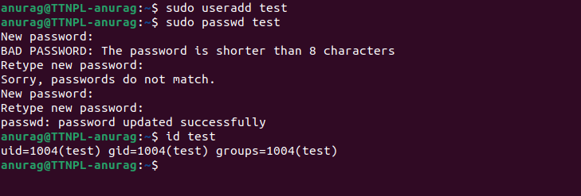

**Q3.(a).** - Login as test user and edit the "output" file created above. Since the permission won't allow you to save the changes. Configure such that the test user can edit it.

**Ans -** this output file do not have the required permission it have only read access to group and others so we must change its permission for test user to modify it first change the owner of test user and modify its access permissions by chmod 660 i.e giving read write to user and read write to group and none to others.

Then use the cat >> output command to modify the file and cat output to look at modified file.

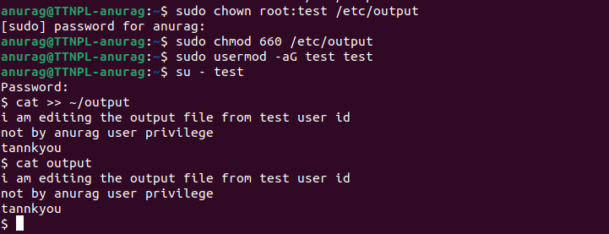

Q3(c , d ).

**Ans**. - now change the ownership of the file from test user back to the root user by ‘sudo chown root:root /etc.output’ command.

We can change the write permission of the group test by check if it has permission and run the command sudo chmod g-w /etc/output.

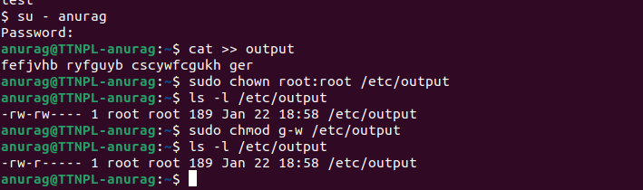

**Q11.** Create alias with your name so that it creates a file as "/tmp/aliastesting".

**Ans -** alias command is used to create an alias. Now to use my name as an alias to create a file as “/tmp/aliastesting” i can create it as ‘alias anurag = ‘touch “/tmp/aliastesting” ‘ and run command as my name ‘anurag’ it will create a file named aliastesting in /tmp folder.

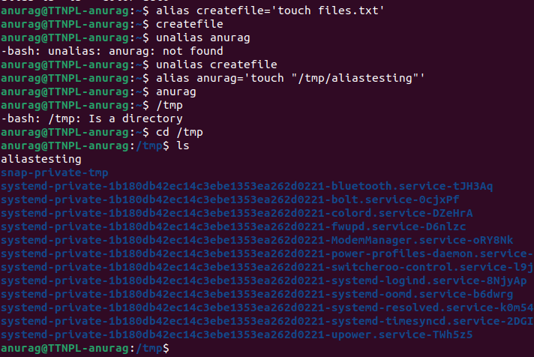

**Q12.** Edit ~/.bashrc file such that when you change to "test" user it should clear the screen and print "Welcome".

**Ans -**  we can edit the ~/.bashrc file using vi or vim editor using command ‘vim ~/.bashrc’ and enter then modify it by enabling input by pressing i button and enter ‘ clear and echo “Welcome” ‘ command in the ~/.bashrc file . and escape from vim usin gEsc the press shift+: and write wq for write and quit thus bashrc ile is edited and executed upon changing the user to test.

**Q13.** Install “zip” package.

**Ans.** - zip is a package in linux that can be used to compress multiple files in one folder with extension as .zip and it can be installed for use in linux using the command sudo apt-get install zip.

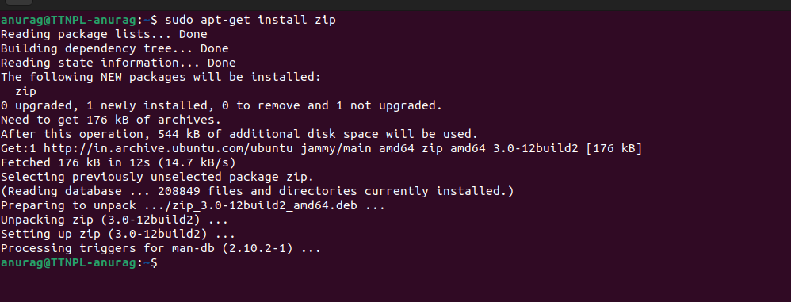

**Q14.** Compress "output" and "password_backup" files into a tar ball. List the files present inside the tar created.

**Ans**. - tar command is used to compress files into a tar file. With options as multiple flags

-cvf archive without compressing

-czvf compress and archive

-xvf extracting archive

-xzvf extracting compressed archive

Now to compress “output” and “passwd_backup” files into tar file to run ‘sudo tar -czvf myarchivedfile.zar.gz output passwd_backup’ command.

-t is used to list the contents of the tar file

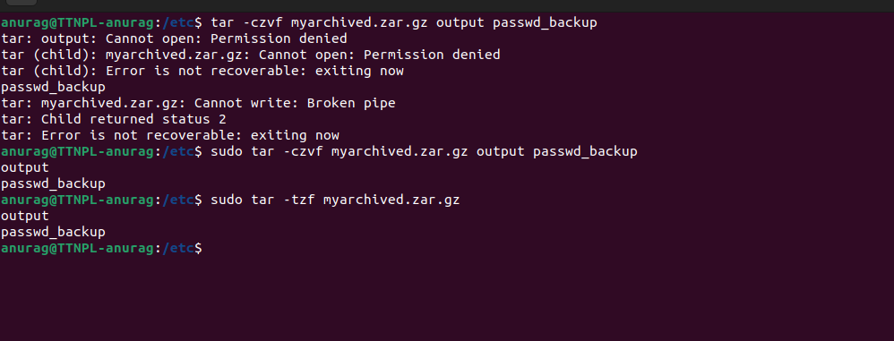

**Q15. s**cp this file to test user home location.

**Ans**. - scp is used for secure copy protocol in a network to transfer the file from remote machine to a local or remote machine. We can also copy a file from one user to another in the same machine as well by using scp as

scp filename_to_transfer username@localhost:location_to_save

=> scp myarchived.zar.gz test@localhost:/home/test

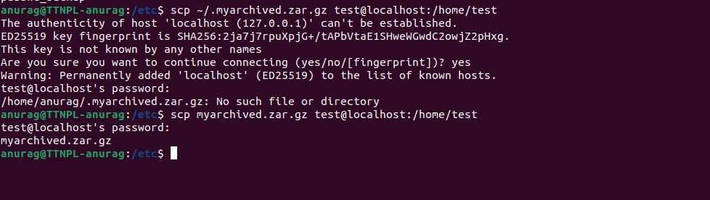

**Q16.** Unzip this tar bar by logging into the remote server

**Ans.** - ssh(secure shell protocol ) is used to log into and access the files from the remote machine.

We can access test user remotely using ssc usrname@ip_adress_ofuser

=> ssh test@localhost because user is on local server this we can access and get the contents of the tar file using tar -tzf filename.zar.gz and get to see the contents inside the file

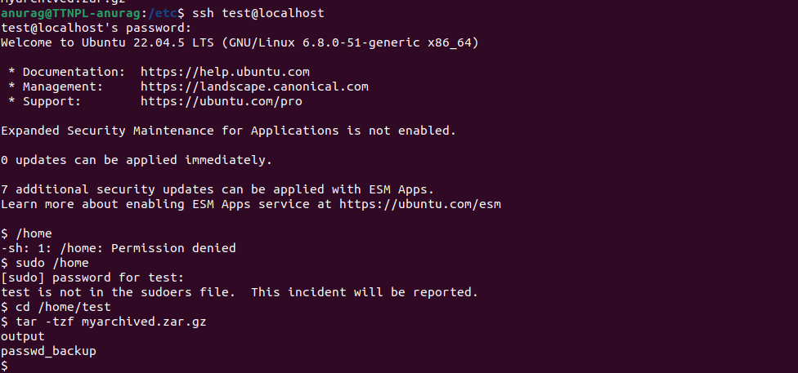

Q17. Download(via cli) any image from web and move(via cli) to test user home location

**Ans. -** files can be downloaded directly from internet using the url of downloadable directly using command line interface with the help of “wget” command.

It do not hinder any other processes as it download files in background.

We can use wget url_of_file to download like

‘wget https://gratisography.com/wp-content/uploads/2024/11/gratisography-augmented-reality-800x525.jpg’

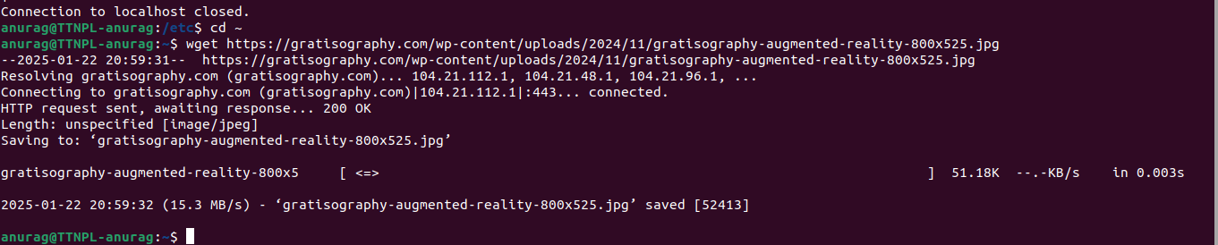

**Q17**. How to get help of commands usages.

**Ans**. - There are multiple ways to get the help about different commands in linux about how they are used , for what they are used and which flag are associated with them

1). Using –help keyword - It provides information regarding each flag and how they are used with the specific commands.

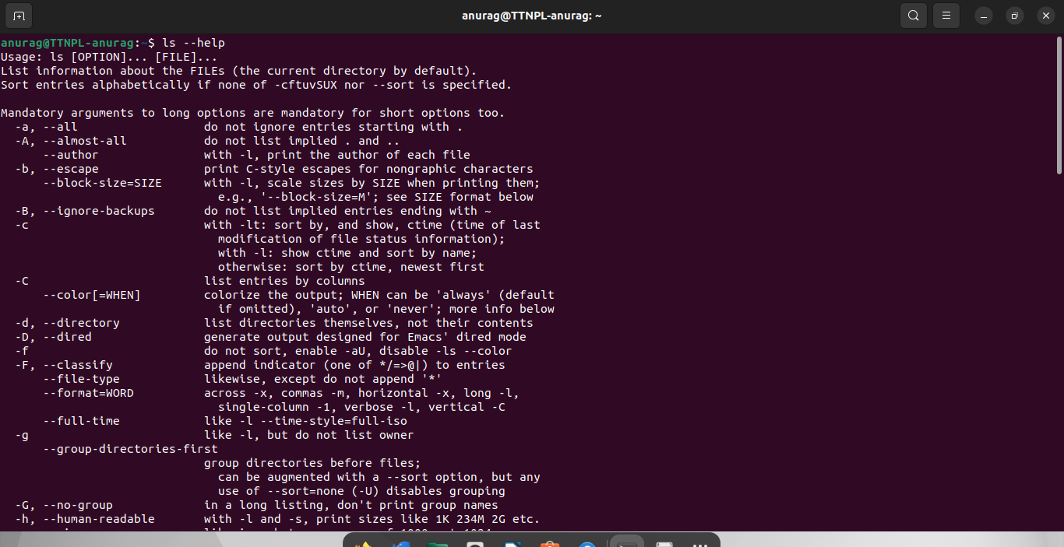

2). Using man command - It provides the detailed manual for the commands, its usages and examples as well

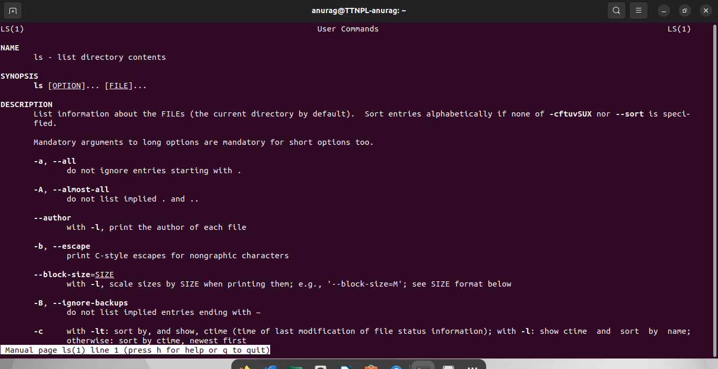

3). Using info command - It is similar to man but provide more detailed information of commands

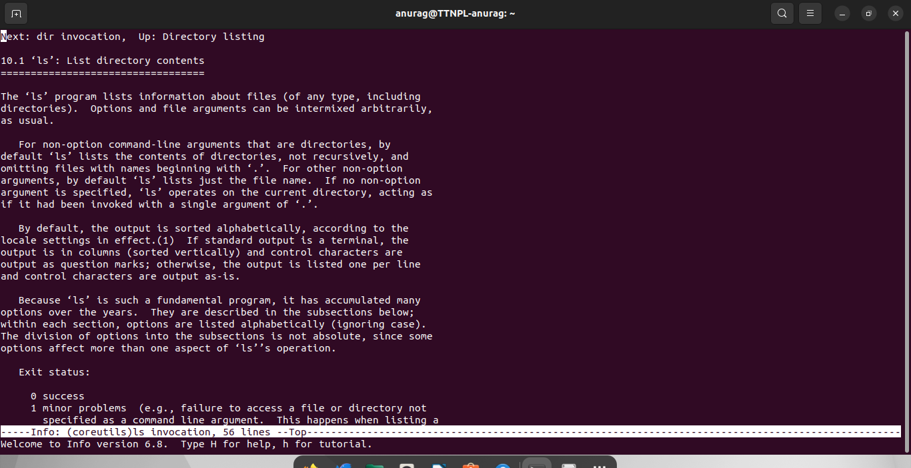

**Q19.** Create a symlink of /etc/services into /tmp/ports-info

Ans. - Symlink is used for symbolic link in which a link is created for a file in another folder or location from where it can be accessed directly by clicking on it.

Symlink is created with -s option which denotes symbolic link

ln -s path_of_service_to_symbolise path_to_directory

Ex. -=> ln -s /etc/services /tmp/ports-info

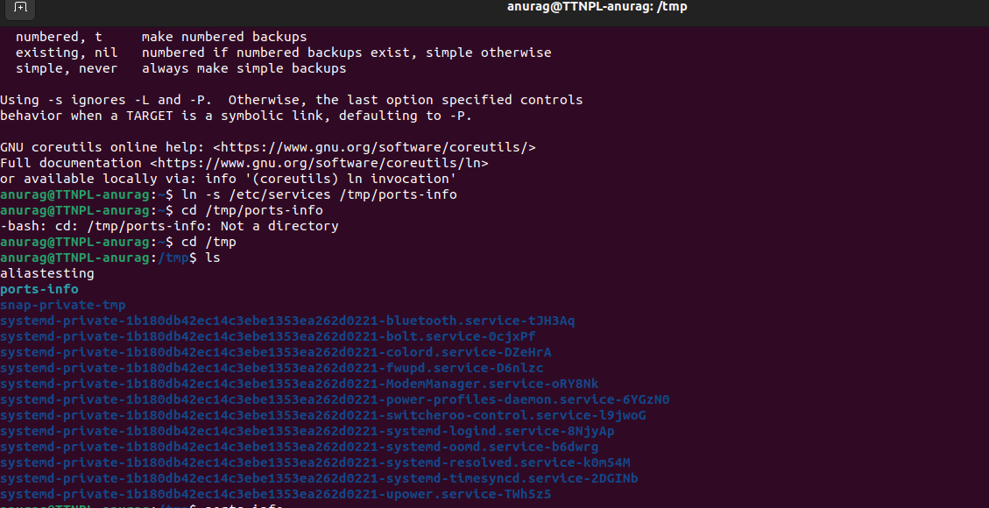

**Q20**. You are appointed as a Software Engineer in ABC media services. On your first day you need to troubleshoot a problem. There is a command “xyz” somewhere installed in that linux system. But as a new joinee you do not have any idea about where is that Installed. How can you check that?

**Ans**. - 1. whereis command_name is used to check where is that command or executable using the database built by system automatically.

2. Which command_name is also used to search for a command in the system

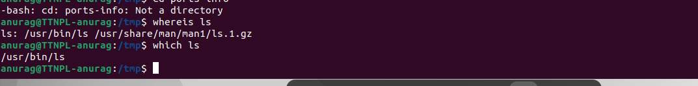

**Q21.** - Analyze the /var/log/syslog file to gather specific information.

**Ans** - a). To find the line with specific word we can use grep(global regular expression print) and in addition to it use head -n to get first 10 lines which contains specific expression in it.

Grep “cron” /var/log/syslog | head

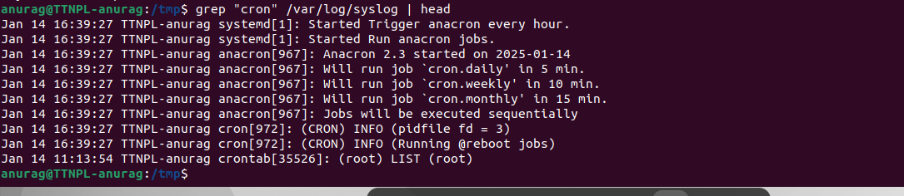

b). Find and display the first 5 lines in the syslog file containing the keyword "error."

Ans - for first lines we can use -n 5 in head command instead of 10

And use word/expression “error”.

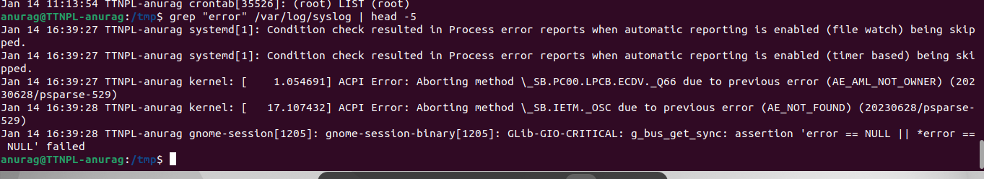

c). Save the last 20 lines of the syslog file containing the word "ssh" to a new file named ssh_errors.log

Ans. - we can use grep to find keyword “ssh” and tail to get last -n lines from the output and store it in ssh_errors.log using the command ‘ grep “ssh” /var/log/syslog | tail -n 20 > ssh_errors.log